**Helter skelter**

**乱作一团**

（英文部分选自经济学人20220709期财经版块）

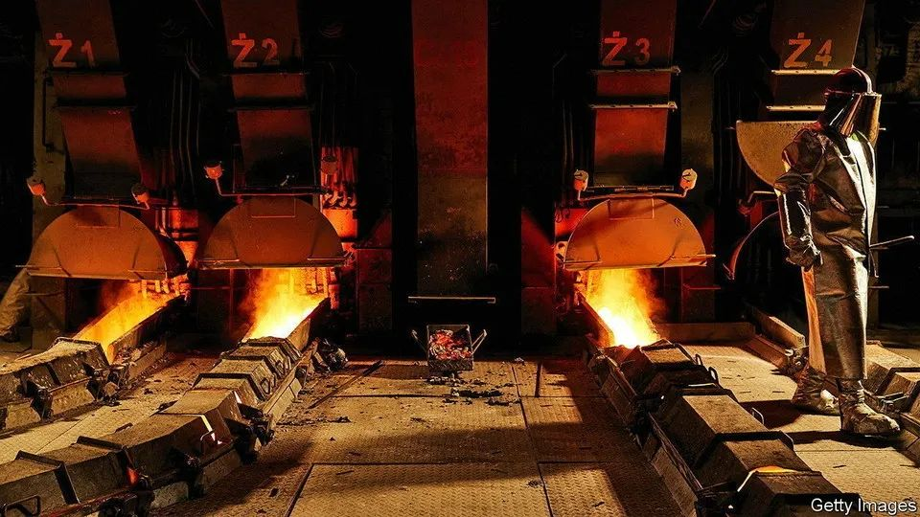

Commodity prices  
大宗商品价格

Helter skelter

乱作一团

The war in Ukraine throttled a flow of raw materials that was already being restricted by logistical logjams, bad weather and other disruptions. The result was soaring prices. In March a barrel of Brent crude oil hit $128, and European gas prices were three times higher than they had been just two months earlier. Copper, a trendsetter for all industrial metals, hit a record price of $10,845 per tonne. Wheat, corn and soyabean prices rose by double-digit percentages. The surge turbocharged consumer-price inflation, which, by challenging central banks’ credibility, has given them another reason to raise interest rates.

本就正囿于物流拥堵、恶劣天气和其他阻碍的原材料供应，又因乌克兰战争遭受致命一击。结果导致原材料价格持续飙升。3月，布伦特原油价格升至128美元/桶，欧洲天然气价格也比仅仅两个月前高出三倍。铜作为所有工业金属的风向标，其价格创下了10,845美元/吨的记录。小麦、玉米和大豆价格的增幅百分比达到了两位数。价格飙升加剧了消费者价格通胀，进而挑战各国央行信誉，成为央行加息的又一理由。

Yet in recent weeks the wind has changed. Oil **is trading at** around $100 a barrel. Copper has dropped below $8,000 a tonne for the first time in 18 months; metals in general have fallen by 10-40% since May. Agricultural-commodity prices are back at pre-war levels. (Europe’s gas prices, which have continued to rise as Russia has cut supply, are bucking the trend.) The slide may fuel hopes that inflation will soon be defeated. But the victory might prove hollow—if there is one at all.

然而，近几周风向已变。原油交易价为100美元/桶左右。铜价自18个月以来首次跌破8000美元/吨；自5月以来，金属价格总体上已下跌10％至40％。农产品价格已回落到战前水平。（由于俄罗斯削减了天然气供应，欧洲天然气价格继续逆势上涨。）价格的下滑可能点燃人们对于通胀很快会被终结的希望。然而，即使真的能迎来胜利，那可能也只是表面胜利。

One explanation for tanking commodity prices is that worries about a recession are taking hold. In this view, rising interest rates are cooling the market for new homes, dampening demand for building materials such as copper and wood, and lowering spending on things like clothing, appliances and cars, which in turn hurts everything from aluminium to zinc. Moreover, some of the supply constraints that contributed to price rises earlier in the year have eased—the weather in grain-growing regions has improved, for instance. Meanwhile, the un is trying to end a blockade on Ukraine’s shipments of wheat.

大宗商品价格暴跌的一种解释是，对经济衰退的担忧愈演愈烈。这样看来，提高利率正在给新房市场降温，抑制对铜和木材等建筑材料的需求，降低服装、电器和汽车等方面的支出。这又进而影响了包括铝和锌在内的众多原材料。再者，导致今年早期物价上涨的供应限制已有所缓解，比如粮食产区的天气已经改善。同时，联合国正积极解决（运输港口）封锁问题，以帮助乌克兰小麦顺利出口。

For central banks, this is **mixed news**. It suggests that inflation may be beaten even though they have only just begun tightening monetary policy. True, this might be accompanied by a recession, but, because inflation would be tamed without interest rates having to rise too much, **the downturn would, perhaps, at least be shallow**.

对各国央行而言，**这条消息喜忧参半**。这意味着即使它们才刚开始收紧货币政策，通胀也可能被控制住。诚然，随之而来的可能是一场经济衰退。不过，由于通胀得以控制，而利率涨幅不高，**因此经济衰退可能只是浅层次的**。

Worries about the economy **are not the only force pushing down prices.** Much of the money that has fled commodities, say industry experts, belongs not to physical traders but to financial punters. In the week to July 1st about $16bn flowed out of commodity-futures markets, bringing the total for the year so far to a record $145bn, according to JPMorgan Chase, a bank. In part that reflects rising interest rates. In May America’s long-dated real rates turned positive for the first time since 2020. That made commodities, which do not offer a yield, less attractive to speculators.

对经济的担忧**并不是推动价格下降的唯一动力**。行业专家表示，许多流出大宗商品的资金并不属于实物交易者，而是属于金融投机者。根据摩根大通银行的数据，截止7月1日前这周，大约160亿美元从大宗商品期货市场流出，而今年迄今为止的流出总额创下了1450亿美元的记录。这在一定程度上也反映出了利率的上涨。5月，美国长期实际利率实现两年来首次转正，导致没有给出收益率的大宗商品对投机者吸引力降低。

注：告别“负利率”——美国实际利率走高及转正的影响<http://news.hexun.com/2022-05-23/205997948.html>

**This suggests** that **commodity-price** inflation may not have been slayed. Movements driven by real-rate swings are usually short-lived, says Tom Price of Liberum, an investment bank. The last time one happened, in 2013, prices stabilised within weeks. Prices **are also still sensitive to** further supply disruptions. Commodity stocks remain 19% below historical average at a time of tight production, meaning there is less of a buffer against shocks.

**这表明大宗商品价格**通胀可能并未得到遏制。Liberum投资银行的汤姆·普莱斯（Tom Price）表示，实际利率波动导致的变动通常都是短期的。上一次的类似情况发生在2013 年，当时大宗商品价格在几周内稳定了下来。大宗商品价格也对长期的供应受阻十分敏感。大宗商品库存仍然比历史其他产能吃紧时期的平均水平下降少19%，这意味着抵抗冲击的缓冲力量更加有限。

注释：La Niña：（拉尼娜是西班牙语“La Niña”——“小女孩，圣女”的意思），拉尼娜现象就是太平洋中东部海水异常变冷的情况，是厄尔尼诺现象的反相，也称为“反厄尔尼诺”或“冷事件”，它是指赤道附近东太平洋水温反常下降的一种现象，表现为东太平洋明显变冷，同时也伴随着全球性气候混乱，总是出现在厄尔尼诺现象之后。摘要：欧洲央行加息后，近日大宗商品价格开始回调，然而这并不代表抗通胀去的成功，相反可能是预示着经济衰退的到来。